Fighting For A Cause
Read the text and complete the table with the required information.
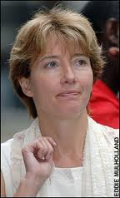
“The Oscar-winning actress, Emma Thompson, yesterday accused Tesco of subjecting its South African fruit pickers to “appalling” pay and conditions.
Thompson, an ambassador for the anti-poverty campaigners Action Aid, claimed women in the Western Cape were unable to feed their children on wages less than 50p an hour and called on the Government to take action against the supermarket.
Thompson, 48, who toured the Western Cape in February, said: “I have visited these farms and I was shocked at what I saw.”
She said 80 women worked from 7am to 6pm for the equivalent of just 38p.
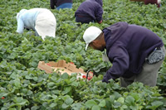
Her comments came ahead of Tesco’s annual general meeting in London today at which one of the workers is expected to speak for the second year about her plight and that of her colleagues.
Jonathan Church, Tesco’s media director, said: “We have looked at the farm conditions and pay, gone over all the allegations made and not found any evidence to suggest there is a problem.”
Daily Telegraph, 29th June 2007
http://www.telegraph.co.uk/news/main.jhtml?xml=/news/207/06/29/ntesco129.xml

Who? | What? | How? | When? | Where? | Why?

Follow-up
Search on the internet for other famous people who are ambassadors for important international organisations. Write about some of those ambassadors, their organisations, the type of work they do, places where they have been to and other information you find relevant. You can also illustrate your work with pictures of those ambassadors, the countries where they played a part, the people they helped. Share your work with your classmates.

