**Food worries**

**🖵 LEAD-IN**

**TASK 1 🢡 Answer the following questions.**

1. Do you do physical exercise every day?
2. What is your favourite sport?
3. How important is physical activity to you?
4. Why is nutrition related to physical activity?

____________________________________________________________________

**🖵 READING**

**TASK 1 🢡 Read the following text carefully.**

Chronic diseases account for 7 of every 10 US deaths and for more than 60% of medical care expenditures.

Much of the chronic **disease** burden is preventable. Physical **inactivity** and unhealthy eating contribute to obesity, cancer, cardiovascular disease, and diabetes. Together, they are responsible for at least 300,000 deaths each year. Only tobacco use causes more preventable deaths in the United States.

Regular physical activity substantially reduces the risk of dying of coronary heart disease, the nation’s leading cause of death, and decreases the risk for many diseases and high blood pressure. It also helps to control weight; contributes to healthy bones, muscles, and joints. Moreover, physical activity need not be **strenuous** to be beneficial; people of all ages benefit from moderate physical activity, such as 30 minutes of brisk walking five or more times a week.

Despite the proven benefits of physical activity, more than 60% of American adults do not get enough physical activity to provide health benefits. More than 25% are not active at all in their leisure time.

But, insufficient physical activity is not limited to adults. More than a third of young people in grades 9-12 do not regularly **engage** in **vigorous** physical activity.

***The Critical Role of Healthy Eating***

We now know that good nutrition lowers the risk for many chronic diseases. Americans are slowly adopting healthier diets, but a large **gap** remains between recommended dietary patterns and what Americans actually eat.

Poor eating habits are often established during childhood. More than 60% of young people eat too much fat, and less than 20% eat the recommended five or more **servings** of fruits and vegetables each day.

[**http://www.cdc.gov/nccdhp/aag/aag-dmpa.htm**](http://www.cdc.gov/nccdhp/aag/aag-dmpa.htm)

**Glossary: 1) expenditure:** the total amount of money that someone spends during a particular period of time

**2) burden:** something difficult or worrying that you are responsible for

**TASK 2 🢡 Are these statements *True* or *False*? Correct the false ones and quote statements from the text to prove the true ones.**

1. Chronic diseases prevent the quality of life. 🖵
2. Most of death problems can be avoided. 🖵
3. Physical activity contributes to heart attacks. 🖵
4. Physical exercise should be done by everyone. 🖵
5. Young people generally have a poor diet. 🖵

**TASK 3 🢡 Answer the following questions according to the text.**

1) Physical activity and good nutrition are the basis of a good health. Explain this statement.

2) Why is it so beneficial to do physical exercise?

3) Why is much of the chronic disease burden preventable?

4) How many times per week should we walk half an hour?

5) What percentage of the American grown-up population doesn’t exercise sufficiently?

6) When do most unsatisfactory eating habits usually begin?

**TASK 4 🢡 Match the words on the left with the right equivalent or explanation on the right.**

1. disease ⇒ …… a) big difference
2. inactivity ⇒ …… b) keep interest
3. reduces ⇒ …… c) using a lot of energy and determination
4. strenuous ⇒ …… d) illness
5. engage ⇒ …… e) makes smaller
6. vigorous ⇒ …… f) needing great effort
7. gap ⇒ …… g) the fact that someone is not doing anything
8. servings ⇒ …… h) an amount of food that is enough for one person

**🖵 VOCABULARY**

**TASK 1 🢡 Based on your knowledge and after watching the new US food plate, fill in the food pyramid with the supplied words.**

[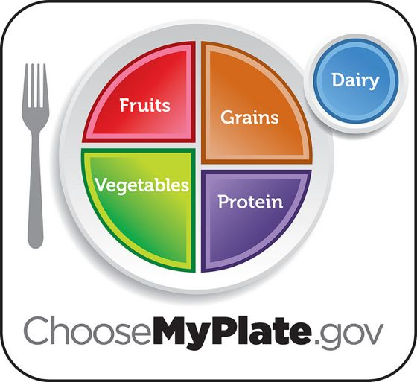](http://www.google.com/url?sa=i&rct=j&q=food%20plate%20usa%202013&source=images&cd=&cad=rja&docid=BpqUWaP0uKiInM&tbnid=vsnkSI8mv4NrJM:&ved=0CAUQjRw&url=http://blogs.houstonpress.com/eating/2013/01/2013_food_trend_a_healthy_stat.php&ei=EuhBUdm6LIKThQezxYDICA&bvm=bv.43287494,d.ZGU&psig=AFQjCNGLy8rbmfgxx87gHA7beMXZVvv4JA&ust=1363360123451320)[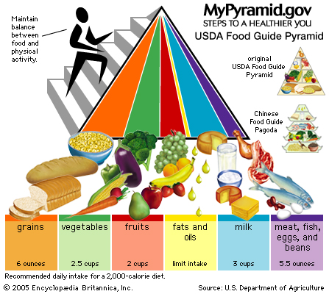](http://www.google.com/url?sa=i&rct=j&q=food%20pyramid%20us&source=images&cd=&cad=rja&docid=7K3v-thfXVuHUM&tbnid=cUCFwmgFK9K2VM:&ved=0CAUQjRw&url=http://www.britannica.com/EBchecked/media/74881/MyPyramid-introduced-by-the-US-Department-of-Agriculture-in-2005&ei=7-hBUf3NO9GFhQeQj4GwBg&bvm=bv.43287494,d.ZGU&psig=AFQjCNFuDgjOFlDckKdasEEYtvxyC8mgbg&ust=1363360355983572)

**A🖙 FRUITS B🖙MILK C🖙 MEAT, FISH, EGGS AND BEANS**

**D🖙 FATS AND OILS E🖙 GRAINS F🖙 VEGETABLES**