CONSUMERISM WORKSHEET

Task 1: Read the poem by Ezra Pound and answer the questions below.

When I carefully consider the curious habits of dogs
I am compelled to conclude
That man is the superior animal.

When I consider the curious habits of man
I confess, my friend, I am puzzled.
- What message is conveyed?
- Identify the key words.

Task 2: Match the words in column A to the corresponding definition in column B.

Vocabulary | Equivalents | Translation
- consumer | - something that you buy / (v. To buy)
- consumerism | - compulsive shopper
- consumption | - buyer
- shopper | - the amount used or eaten
- spendthrift | - someone who spends a lot of money in a wasteful way
- shopaholic | - a person who buys goods or a service
- customer | - too much attention is given to buying and owning things
- purchase | - a person that consumes

1)... 2)... 3)... 4)... 5)... 6)... 7)... 8)...

Task 3: Read this newspaper article to answer the questions below.

Consumerism and Consumption in our Modern Society
The rise of consumerism in the “developed world” occurs as buying habits are transformed, and luxuries are turned into necessities.
The idea of getting more and more helps to stir up anxieties, greediness and restlessness over the possession of things. Fashion pressures people to buy out of need, just for style, to be conform to what others define as fashionable. But as well as meeting consumers’ desires there is a more fundamental political and economic reason for promoting consumerism. That is, this support for fashion is seen as very valuable because it is a subtle form of imposing social control, as people become more individualist, turn more inwards on themselves. People who were once concerned about social issues are now largely transformed into exploring and fulfilling their individual desires through the purchase of material goods.

Task 4: Find equivalents in the text for these words/expressions.

growth | cause an unpleasant sensation | wanting a lot more than you need | feeling unable to be calm | in popular and modern style | matching | satisfying | buying

Task 5: Answer these questions in your notebook.

- What exactly makes consumers buy things?
- Why is it dangerous to promote individualism?

Task 6: Now listen to this song by Madonna and discuss the intended message.

Task 7: Now listen to the song again and fill in the blanks.

⇒ You are going to listen to this song twice. The gaps take more than one word!

Do I have to change my name?
________________________________?
Should I lose some weight?
Am I gonna be a star?
(...)
This type of modern life – Is it for me?
This type of modern life – __________________?

So, I went into a bar looking for sympathy
_________________ – I tried to find a friend
It’s more easily said, it’s always been the same
This type of modern life is not for me.
This type of modern life________________________________ .
(...)
I tried to stay ahead,
I tried to stay on top,
I tried to play the part,
But I forgot
Just what I did it for
And why I wanted more
This type of modern life – Is it for me?
This type of modern life– __________________?
(...)
I got a lawyer and a manager
An agent and a chef
Three nannies, an assistant
And a driver and a jet
A trainer and a butler
And a bodyguard or five
A gardener and a stylist

Do you think I’m satisfied?

I’d like to express my extreme point of view
I’m not Christian and I’m not a Jew
I’m just living out the American dream
And I’ve just realized that nothing is what it seems.

Task 8: Guess the title of this song or suggest a suitable one and justify your choice.

- Now reread the lyrics and find out the opposites for the following:
- Gain
- Hostility
- Back
- Bottom
- Remember

- Read the lyrics and answer the following questions. Use your own words as far as possible.

- What are the characteristics of this modern life?
- There seems to be a price to pay for this modern life. What is it?
- When the goals of this modern life are achieved, what do people wonder?
- Has the singer achieved those goals? Explain.
- Is she satisfied?
- The last sentence is a sort of conclusion. Explain it.

- Fill in the gaps with the correct tense of the verb in brackets.

- Nowadays people ________(be) worried about __________ (have) a lot of things because they__________ (not/be) able to escape from modern society’s pressure.

- Some years ago most ordinary people ___________ (feel) happy with what they __________ (have) although they ___________ (not/have) much.

- ____________ (be) very rich and ___________ (have) many things may not _________ (bring) happiness, but it can __________ (help) us to live more comfortably.

- Our society ____________ (become) more and more materialistic since the World War II, but it ___________ (not/make) life easier.

- Now we _____________ (face) more and more pressure to have things and the economic situation __________ (get) intolerable.

Look at this advertisement and comment on the following statement.

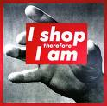 | Living in a consumer society has profound implications on how we behave and relate to others.
The words in the boxes form a quotation by Ghandi. Look at the pictures and try to write it in the correct order.
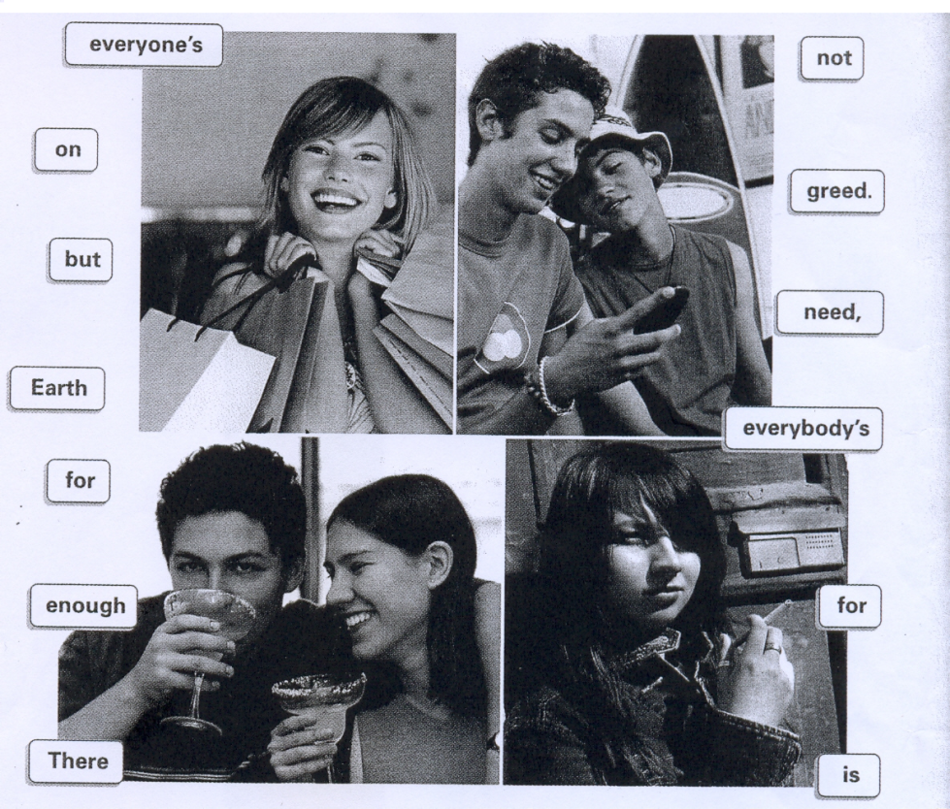

Do you agree with Ghandi’s quotation? Justify.

Choose one of the following topics and write about 80-100 words on it.

- Fast food in US schools.
(Refer to the advantages and disadvantages of fast food.
Say whether you agree with the fact that fast food companies give money to schools to advertise fast food there.)
- Are you a shopaholic?
(Refer to the way you deal with your money, who you get your money from, your shopping habits, shops you prefer, items on which you spend most of your money... )
- Comment on the following: “If you want to feel rich, just count the things you have that money can’t buy”.
Say whether you agree with the message conveyed. Explain the message. Refer to the difficulties in following this advice in modern societies.

